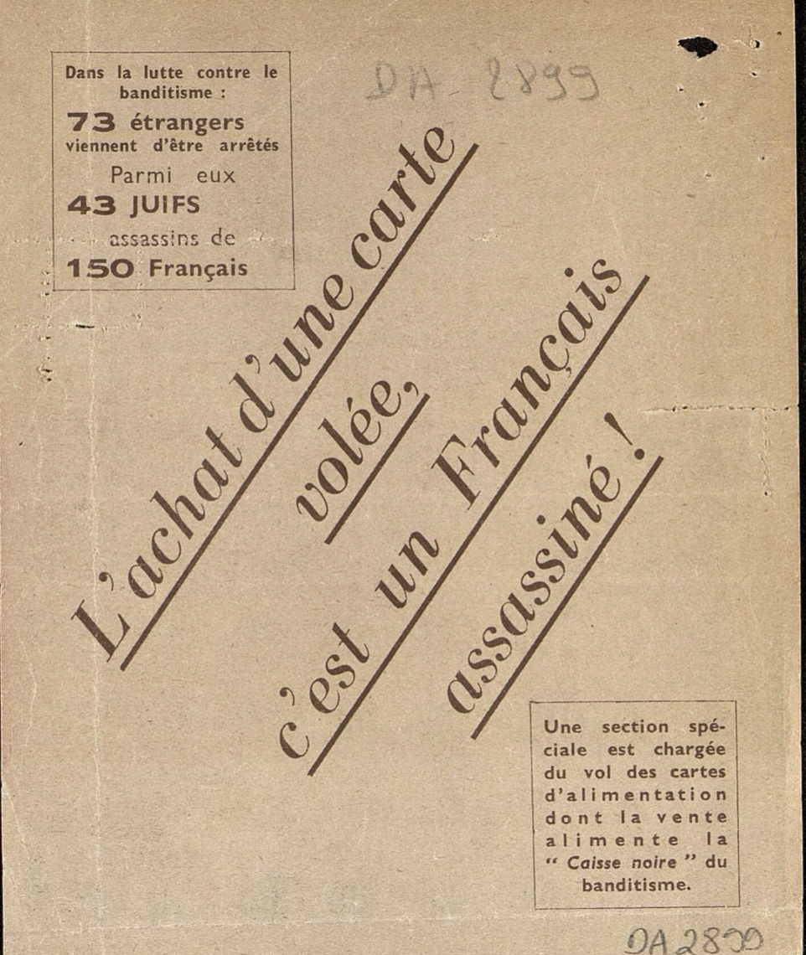

La France sous l’Occupation

Séance 1



**Nom:**

**Prénom:**

**Date:**

|  |  |  |  |
| --- | --- | --- | --- |
| Compétence travaillée | Evaluation | | |
| Analyser et comprendre un document | NA | PA | A |

Verso

Recto

Document 1: Tract distribué dans la commune de Carpentras (6W41), Décembre 1943

**Réponds aux questions par une phrase.**

1. Quelle est la nature de ce document ?

……………………………………………………………………………………………………………………………………………………….……………………………………………….

……………………………………………………………………………………………………………………………………………………….……………………………………………….

……………………………………………………………………………………………………………………………………………………….……………………………………………….

1. Quelle est la date de ce document ?

……………………………………………………………………………………………………………………………………………………….……………………………………………….

……………………………………………………………………………………………………………………………………………………….……………………………………………….

……………………………………………………………………………………………………………………………………………………….……………………………………………….

1. A qui s’adresse ce document ?

……………………………………………………………………………………………………………………………………………………….……………………………………………….

……………………………………………………………………………………………………………………………………………………….……………………………………………….

……………………………………………………………………………………………………………………………………………………….……………………………………………….

1. Que dénonce ce document ?

……………………………………………………………………………………………………………………………………………………….……………………………………………….

……………………………………………………………………………………………………………………………………………………….……………………………………………….

……………………………………………………………………………………………………………………………………………………….……………………………………………….

1. Qui est accusé ?

……………………………………………………………………………………………………………………………………………………….……………………………………………….

……………………………………………………………………………………………………………………………………………………….……………………………………………….

……………………………………………………………………………………………………………………………………………………….……………………………………………….

1. Que risquent les accusés ?

……………………………………………………………………………………………………………………………………………………….……………………………………………….

……………………………………………………………………………………………………………………………………………………….……………………………………………….

……………………………………………………………………………………………………………………………………………………….……………………………………………….

1. Qui est chargé de la lutte contre le banditisme ?

……………………………………………………………………………………………………………………………………………………….……………………………………………….

……………………………………………………………………………………………………………………………………………………….……………………………………………….

……………………………………………………………………………………………………………………………………………………….……………………………………………….